OMICS Deployment Document

Database
Users:
- muser (access to all schema, acts as admin login)
- appuser( has access to only omicsdb schema)
- dev ( has access to only omicsdb schema)
If the IP address of dev user changed ( current IP of dev user is the Qison Public IP ie :- 183.82.98.115) need to modify the user or crete a new dev user with the changed IP
CREATE USER 'dev'@'CHANGEDIP' IDENTIFIED BY 'PASSWORD';
The database schema name should be omicsdb because app and dev users are given access to only omicsdb schema
if any other schema is created for the production , permission should be given to app and dev user
Steps to give permissions
GRANT ALL ON NEW_DB_SCHEMA_NAME.* TO 'USER'@'IP';
FLUSH PRIVILEGES;
Example:-
CREATE USER 'appuser'@'172.41.1.%' IDENTIFIED BY '_x7RF!qi0@omiCs';
GRANT ALL ON alliedacadproddb.* TO 'appuser'@'172.41.1.%';
FLUSH PRIVILEGES;
Note :- 172.41.1.% will be the private ip of the apllication server

Changes in the Code for production

- Cross check the CF url in all four index.htmls
- Crosscheck the Solr configuration (schema names) in SolrConfig and all the respective cores
- If there are any Changes in the Proceedings htmls(Pdf) the Proceedings folder in both Application servers should be update
location of Proceedings in application server :-/root/OMICS_HOME (Note to acesses this location you should be logged in as root user , use sudo -s command to log in as root user)

Steps For Deloping the Project in the Tomcat Server

- There are two application servers, for deployment we need to copy the war file to both the servers
- The war file name should be omics02.war, to change the name of war file we need to change the setting in server.xml
location of server.xml ;- /home/ec2-user/apache-tomcat-8.0.24/conf
<Context reloadable="true" path="" docBase="omics02"/> replace the highlighted part with the required war file name
- Prepare the war file of the application
- login to the Server through EC2 instance
- After login to the server, change the user to root
command:- sudo -s
- Copy the war file to webapps (location:- /home/ec2-user/apache-tomcat-8.0.24/webapps)
- Stop the Server if running

- Crosscheck weather the server is running
command:- netstat -nptl
- If the server is running either kill the process or stop the server
command :- kill -9 processId
sudo /home/ec2-user/apache-tomcat-8.0.24/bin/shutdown.sh
- If any ROOT folder is present in the /home/ec2-user/apache-tomcat-8.0.24/webapps either delete or rename the folder
- Now start the server
sudo /home/ec2-user/apache-tomcat-8.0.24/bin/startup.sh

Note:- Once both the servers are started , cross check the status of the server in the aws management console in the coresponding load balancers

Steps For Solr Reindexing Solr

Solr is installed in the mounted device storage1 in the Sole/memcached server
location : storage1/Solr
1 Delete data from the respective solr
1.1. http://SolrPublicIP:8983/solr/country/update?stream.body=%3Cdelete%3E%3Cquery%3E*%3A*%3C%2Fquery%3E%3C%2Fdelete%3E&commit=true
1.2 http://SolrPublicIP:8983/solr/state/update?stream.body=%3Cdelete%3E%3Cquery%3E*%3A*%3C%2Fquery%3E%3C%2Fdelete%3E&commit=true
1.3. http://SolrPublicIP:8983/solr/city/update?stream.body=%3Cdelete%3E%3Cquery%3E*%3A*%3C%2Fquery%3E%3C%2Fdelete%3E&commit=true
1.4. http://SolrPublicIP:8983/solr/subject/update?stream.body=%3Cdelete%3E%3Cquery%3E*%3A*%3C%2Fquery%3E%3C%2Fdelete%3E&commit=true
1.5 http://SolrPublicIP:8983/solr/conferenceListingPage/update?stream.body=%3Cdelete%3E%3Cquery%3E*%3A*%3C%2Fquery%3E%3C%2Fdelete%3E&commit=true
1.6 http://SolrPublicIP:8983/solr/keyword/update?stream.body=%3Cdelete%3E%3Cquery%3E*%3A*%3C%2Fquery%3E%3C%2Fdelete%3E&commit=true
1.7 http://SolrPublicIP:8983/solr/university/update?stream.body=%3Cdelete%3E%3Cquery%3E*%3A*%3C%2Fquery%3E%3C%2Fdelete%3E&commit=true
1.8. http://SolrPublicIP:8983/solr/conference/update?stream.body=%3Cdelete%3E%3Cquery%3E*%3A*%3C%2Fquery%3E%3C%2Fdelete%3E&commit=true
1.9. http://SolrPublicIP:8983/solr/user/update?stream.body=%3Cdelete%3E%3Cquery%3E*%3A*%3C%2Fquery%3E%3C%2Fdelete%3E&commit=true

2. Copy data to respective solr

2.1 http://domainname/Search/copyToSolr?fromid=1&toid=1000
(toid will be the number of conference present in the database)
2.2 http://domainname/Search/copyUsersToSolr?fromid=1&toid=1000
(toid will be the number of users present in the database)
2.3 http://domainname/Search/copyUniversitiesToSolr
2.4 http://domainname/Search/copyCountriesToSolr
2.5 http://domainname/Search/copyStatesToSolr
2.6 http://domainname/Search/copyCitiesToSolr
2.7 http://domainname/Search/copySubjectsToSolr
2.8 http://domainname/Search/copyKeywordsToSolr
2.9 http://domainname/Search/ConferenceListingPageToSolr
Note: Replace domainname with the domain if project is already deployed

GZIPPING FILES(JS/CSS) USING GRUNT

- 1.As we all know grunt is used for the concatination(combining multiple js/css files into a single js/css file) and it is also used to convert normal js/css files into the minified or gzipped versions.

GRUNT FOR THE DASHBOARD:

- As we know we have four dashboards(cnfadmin,sysadmin,unvadmin and management) in our system
- Each dashboard has different index.html
- Each index.html has different resources(js/css)
- Each index.html consists of multiple custom(files which we have written externally for our system) js and css files and also the multiple library js and css files

- Now we have to combine all the custom js and css resources into single js and css file and also for all the library js and css files into the single js and css file for each index.html

- Create a new folder in your machine outside the project and set an environment to run grunt file and lets name this folder as 'Grunt_For_Dashboard'.
- Now place our GruntFile(For Dashboard).js from our OMICS project into this folder and rename the 'GruntFile(For Dashboard)' to 'GruntFile'.

- In our system 'Configuration.js' , 'App.js' and 'RequestManager.js' are being used in all the dashboards, so its better to keep these files in a single folder

- Create a folder with name 'CommonFiles' in 'Grunt_For_Dashboard' folder.
- Now place the 'Configuration.js' , 'App.js' and 'RequestManager.js' in the 'CommonFiles' folder.

- Open the index.html of the cnfadmin dashboard and note down all the custom js that is getting used.
- Create a new folder with name 'cnfadmin' in 'Grunt_For_Dashboard' folder.
- Now place all the cnfadmin custom js files into the 'cnfadmin' folder.

- Open the index.html of the sysadmin dashboard and note down all the custom js that is getting used.
- Create a new folder with name 'sysadmin' in 'Grunt_For_Dashboard' folder.
- Now place all the sysadmin custom js files into the 'sysadmin' folder.

- Open the index.html of the unvadmin dashboard and note down all the custom js that is getting used.
- Create a new folder with name 'unvadmin' in 'Grunt_For_Dashboard' folder.
- Now place all the unvadmin custom js files into the 'unvadmin' folder.

- Open the index.html of the management dashboard and note down all the custom js that is getting used.
- Create a new folder with name 'management' in 'Grunt_For_Dashboard' folder.
- Now place all the management custom js files into the 'management' folder.

- Create a new folder with name 'custom-css' in 'Grunt_For_Dashboard' folder.
- Now place a 'dashboard-custom.css' in 'custom-css' folder.

- Create a new folder with name 'library-css' in 'Grunt_For_Dashboard' folder.
- Make note of all the library css files used in all the dashboards(check in all four index.htmls)
- Now place all the files in 'library-css' folder.

- Create a new folder with name 'library-js' in 'Grunt_For_Dashboard' folder.
- Make note of all the library js files used in all the dashboards(check in all four index.htmls)
- Now place all the files in 'library-js' folder.

- Create a new folder with name 'non-concatinated' in 'Grunt_For_Dashboard' folder.
- Now place 'bootstrap-datetimepicker.min' and 'jquery-jvectormap-1.2.2.min' files which are there in our system in 'non-concatinated' folder.

- Make sure our folder structure is like below

Grunt_For_Dashboard(Main Folder)
---->cnfadmin(sub folder)
---->sysadmin(sub folder)
---->unvadmin(sub folder)
---->management(sub folder)
---->custom-css(sub folder)
---->library-css(sub folder)
---->library-js(sub folder)
---->non-concatinated(sub folder)

- Now we have completed placing files in the respected folders, its time to run GruntFile
- Go to the Grunt_For_Dashboard's folder location using command prompt
and run the simple command named 'grunt'

- After running the 'grunt' command you can see that a folder named 'Combined' is created
- Go to the 'Combined/gzip' folder and you can see the gzipped files named 'cnfadmin.min.gz','sysadmin.min.gz','unvadmin.min.gz','management.min.gz' and 'libraries.min.gz', now copy these files and go into the OMICS project and place these files in this folder 'OMICS\src\main\resources\public\resources\js\minified'.

- For the minified custom css file go to the 'Combined/css' folder select 'dashboard-custom.min.gz', copy this file and go into the OMICS project and place the file in this folder 'OMICS\src\main\resources\public\resources\css'.

- For the single library css file go to the 'Combined/css/concat' folder select 'dashboard-library.min.gz',copy this file and go into the OMICS project and place the file in this folder 'OMICS\src\main\resources\public\resources\css\lib'
- Note: Dont consider 'dashboard-library.min.gz' in 'Combined/css' folder.

- For cnfadmin index.html replace all the custom js files with 'cnfadmin.min.gz' file and replace all the library files with 'libraries.min.gz' file and replace all the custom css files with dashboard-custom.min.gz and replace all the library css files with dashboard-library.min.gz.

- For sysadmin index.html replace all the custom js files with 'sysadmin.min.gz' file and replace all the library files with 'libraries.min.gz' file and replace all the custom css files with dashboard-custom.min.gz and replace all the library css files with dashboard-library.min.gz.

- For unvadmin index.html replace all the custom js files with 'unvadmin.min.gz' file and replace all the library files with 'libraries.min.gz' file and replace all the custom css files with dashboard-custom.min.gz and replace all the library css files with dashboard-library.min.gz.

- For management index.html replace all the custom js files with 'management.min.gz' file and replace all the library files with 'libraries.min.gz' file and replace all the custom css files with dashboard-custom.min.gz and replace all the library css files with dashboard-library.min.gz.

GRUNT FOR THE WEBSITE:

- As we know we have plain js/css and some minified js/css files in our system.
- Now we have to convert these js/css files into the gzipped versions.

- Create a new folder in your machine outside the project and set an environment to run grunt file and lets name this folder as 'Grunt_For_Website'.

- Now place our GruntFile.js from our OMICS project into the 'Grunt_For_Website' folder.

- Create a new folder with name 'custom-js' in 'Grunt_For_Website' folder.
Now select Configuraion.js',
App.js'
RequestManager.js
header.js
Subscribe.js
- These are the custom js files used in header.html which will loaded in every page
- Copy these files into the 'custom-js' folder
- If you want to add new file into the system then you have to select these files along with your new file and run grunt command

- Create a new folder 'library-js' in 'Grunt_For_Website' folder.
Open header.html and copy all the library js files which are there in the header.html and place those files in the 'library-js' folder

- Please crosscheck the files with the screen below for all the library js files
- If you want to add new file into the system then you have to select these files along with your new file and run grunt command

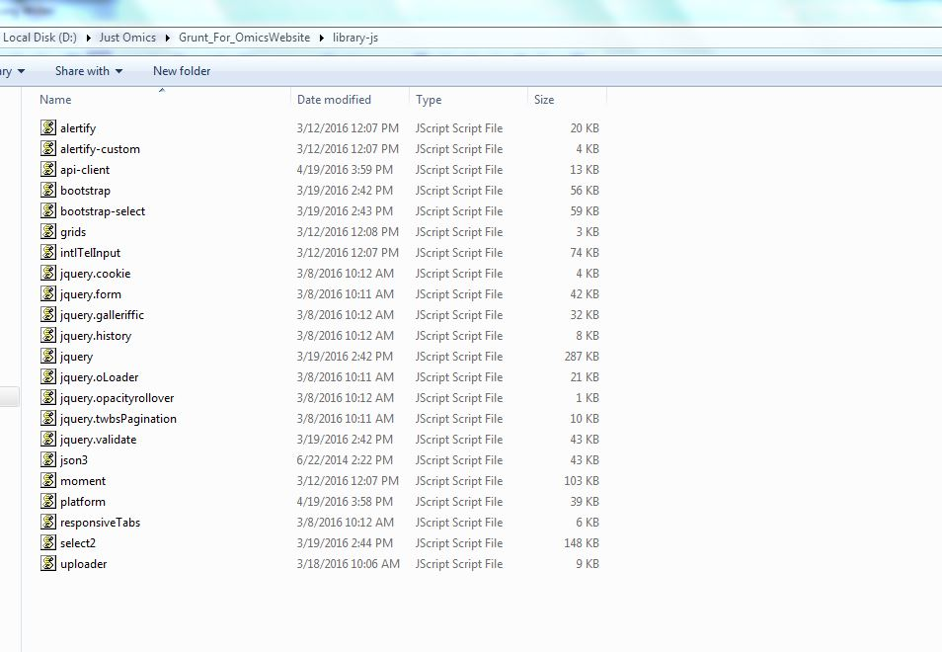

- Open header.html and copy all the library css files which are there in the header.html and place those files in the 'library-css' folder

- Please crosscheck the files with the screen below for all the library js files
- If you want to add new file into the system then you have to select these files along with your new file and run grunt command

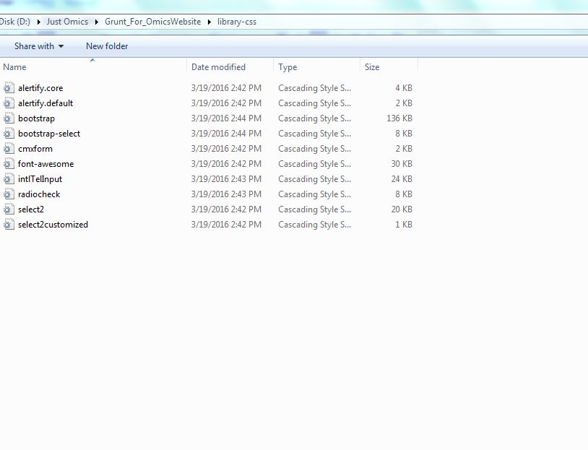

- Go to the Grunt_For_Website's folder location using command prompt
- and run the simple command named 'grunt concat'
- Note:Use the command as 'grunt concat'

- After running this command a new folder would be created with name 'Combined' and open that folder, you can see there will three files named 'combined_custom.js','combined_library.js' and 'combined_library.css'

- Copy 'combined_custom.js' and go into OMICS project and paste the 'combined_custom.js' in 'OMICS\src\main\resources\public\resources\js\minified' folder

- Copy 'combined_library.js' and go into OMICS project and paste the 'combined_library.js' in 'OMICS\src\main\resources\public\resources\js\minified' folder

- Copy 'combined_library.css' and go into OMICS project and paste the 'combined_library.css' in 'OMICS\src\main\resources\public\resources\css\lib' folder

- Now we need to convert the normal js/css and minified js/css files of our system into the gzipped files
- Go to the OMICS project, go into the 'OMICS\src\main\resources\public' folder location and copy the 'resources' folder and place it into the 'Grunt_For_Website' folder

- Go to the Grunt_For_Website's folder location using command prompt
and run the simple command named 'grunt'
- Note:Use the command as 'grunt' only

- After running grunt you can see the new folder named 'grunt-resources' and in that you can find sub-folder named 'gzip'.
- In the 'Grunt_For_'Website\grunt-resources\gzip' folder you can find gzipped files of our system, copy these files into our project in a proper structure.

Note:while running the grunt delete the already presented gzipped files in that location

